1. **INTRODUCTION**
   1. **Overview**

In this project, we see the population level of the global community. The population growth is shown by different methods. There are it is shown by map, line graph, bar graph, pie chart. First in the map we see the record type of the countries. The population of the world is shown by countries in different colours. Next the population trends over the year is defined by the line graph. In this graph, we note that the population is same level in the year of 1970 to 1995 and next the population is increased in few years and decreasing and then increasing. Finally, in the year 2015 the population growth is decreased. Next the population trends over the year by sex is also defined by the line graph. This graph also shows the population increases and decreases both male and female individually. In this graph also we see the decreasing population level in 2015. Next , cities with high population are defined by the bar graph. The bar shows the city of Shangai has the highest population level. This bar graph shows the population by city by city. Then the pie chart represents the population in urban city and proper city. The urban city has the lowest population level. Next , we see the population of cities by year in the table form.

* 1. **Purpose**

In this project, we have to analyse the increasing and decreasing level of the population growth and we have to try to maintain the correct population year by year.

1. **Problem Definition and Design thinking**
   1. **Empathy Map**

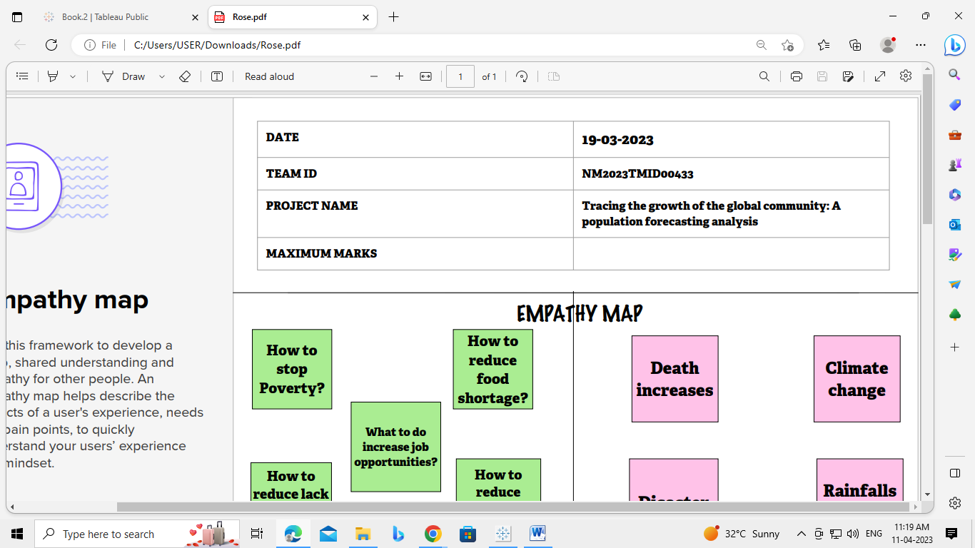

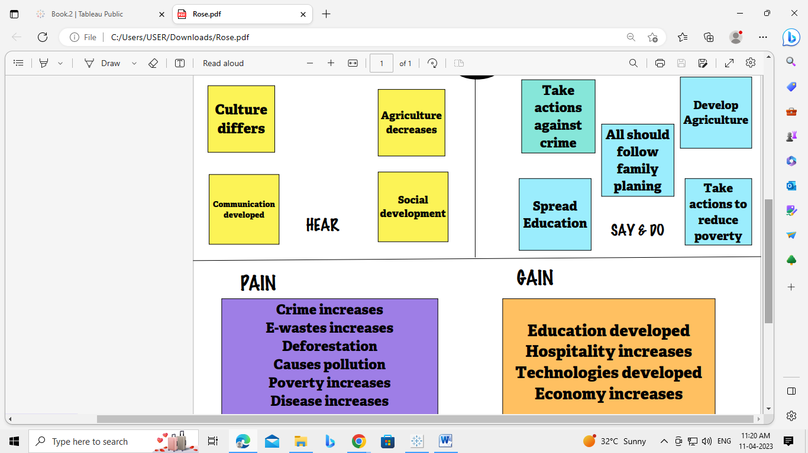

* 1. **Ideation and Brainstorming Map**

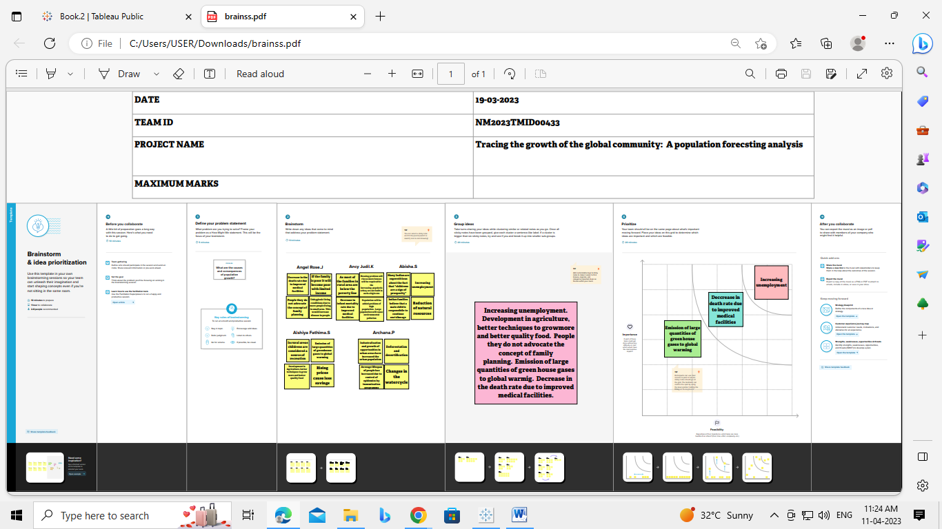

1. **RESULT**

**Dashboard 1**

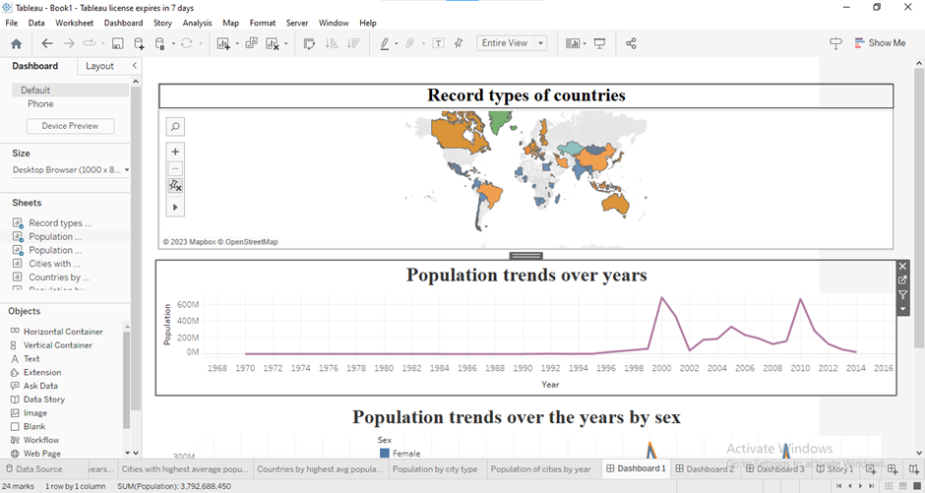

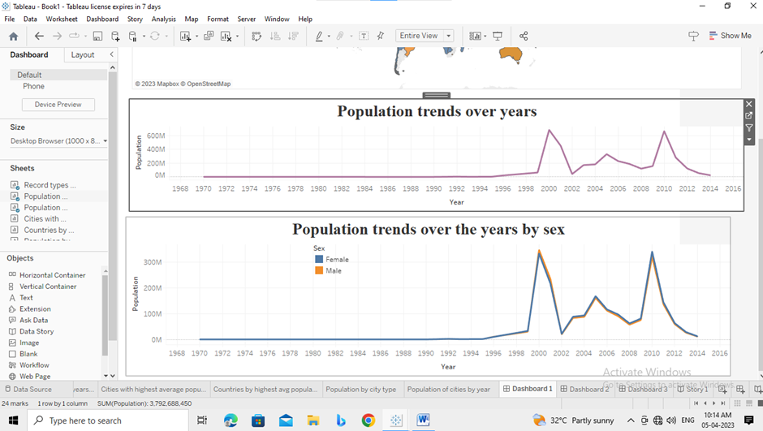

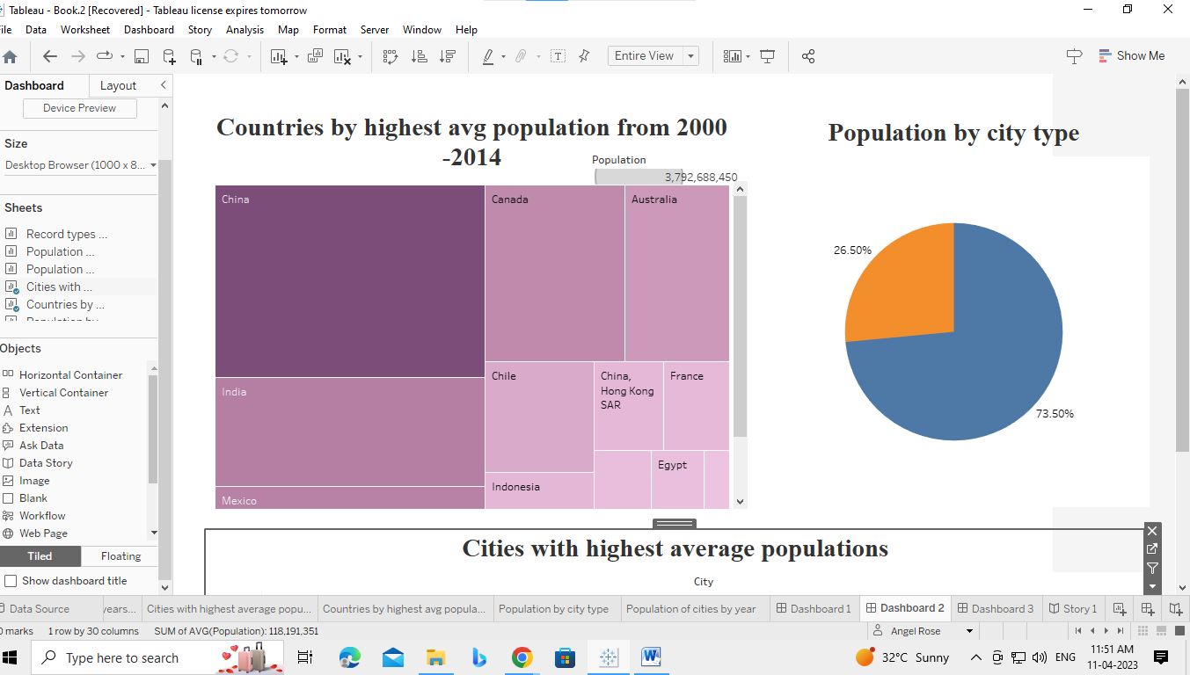**Dashboard 2**

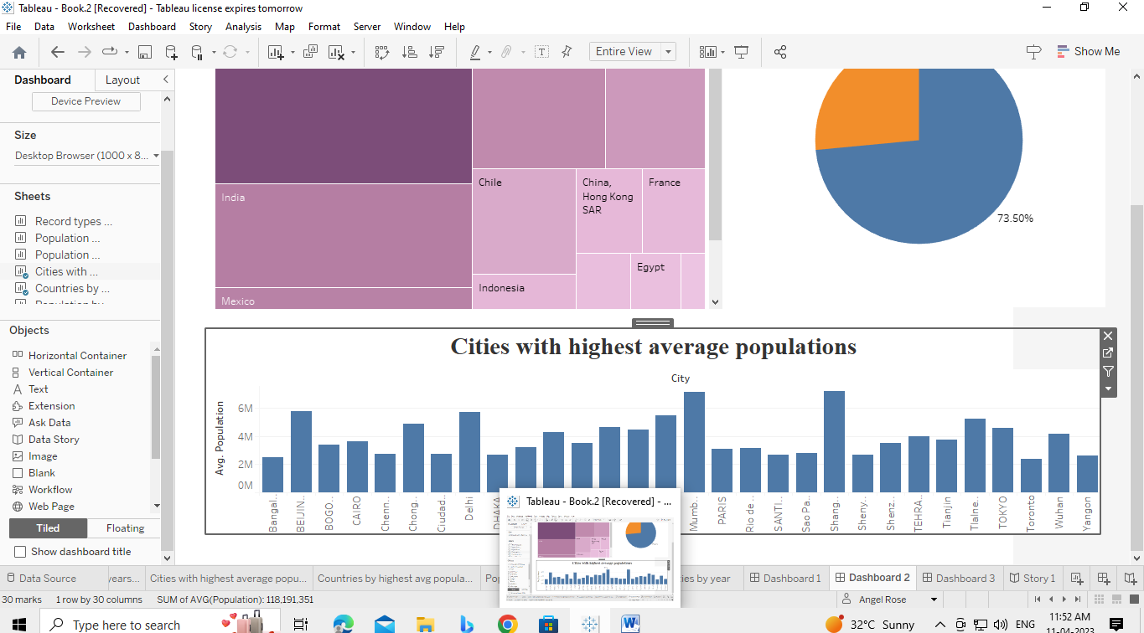

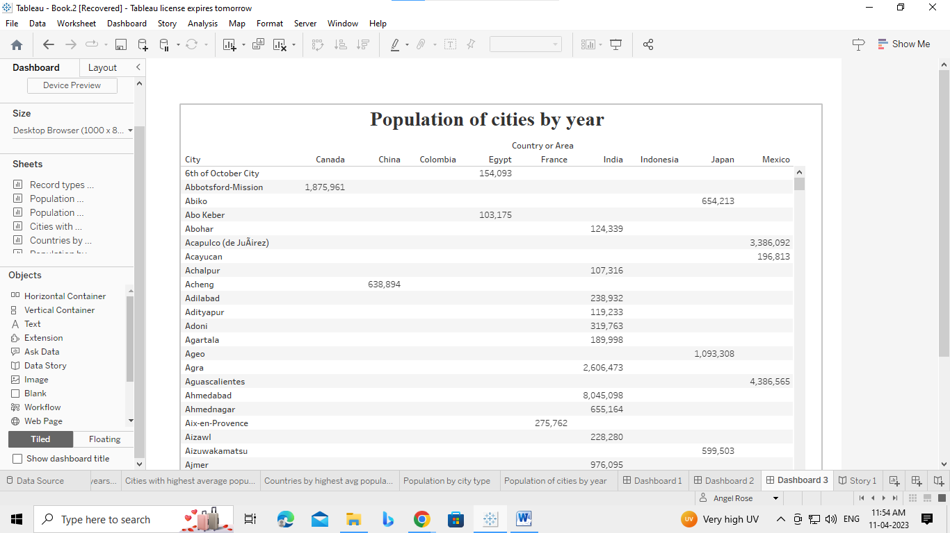**Dashboard 3**

**Story**

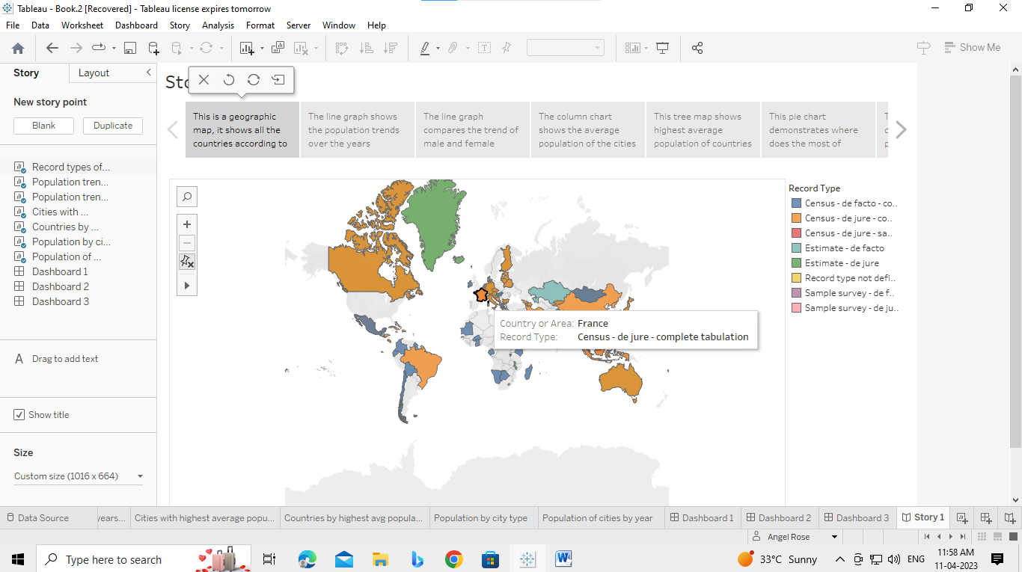

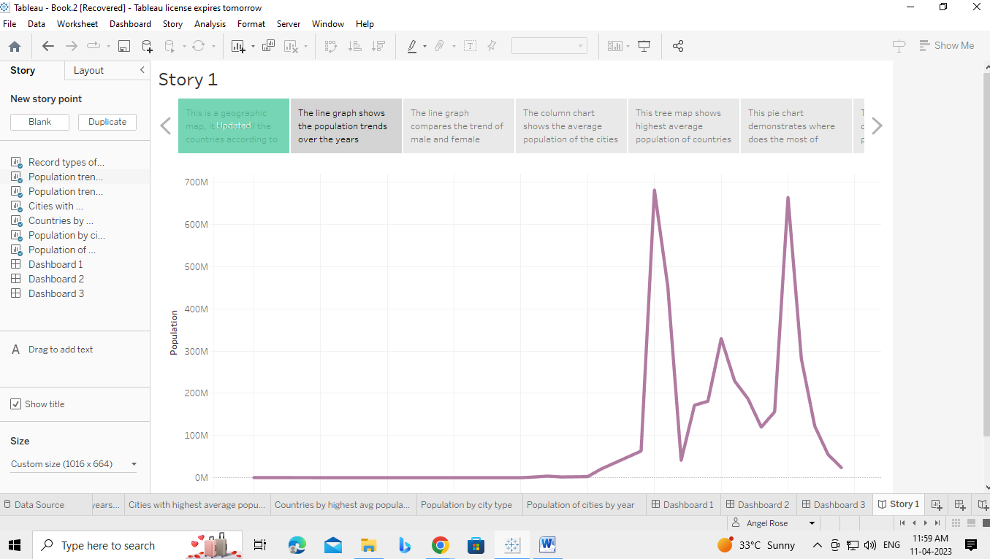

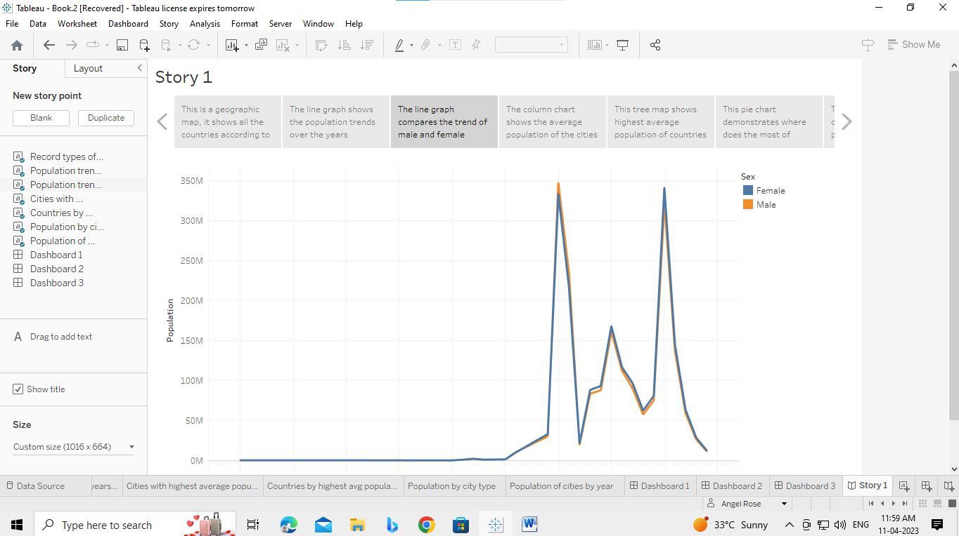

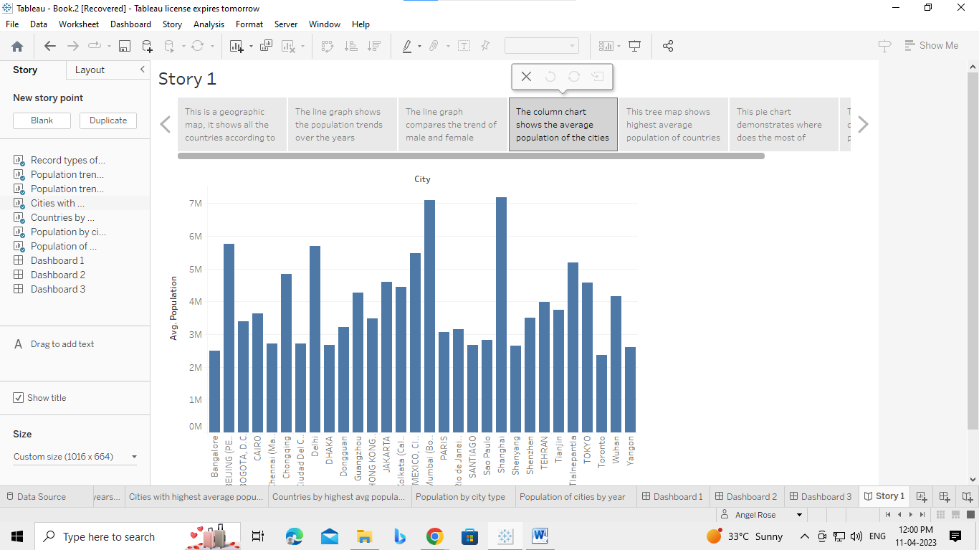

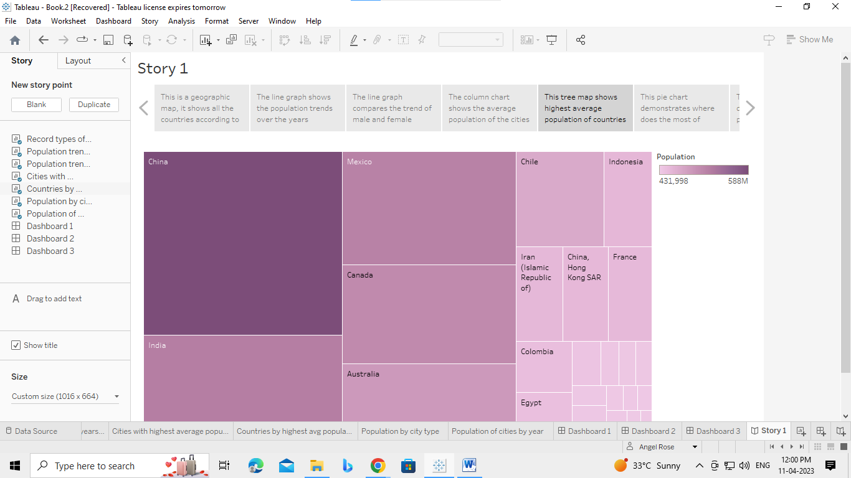

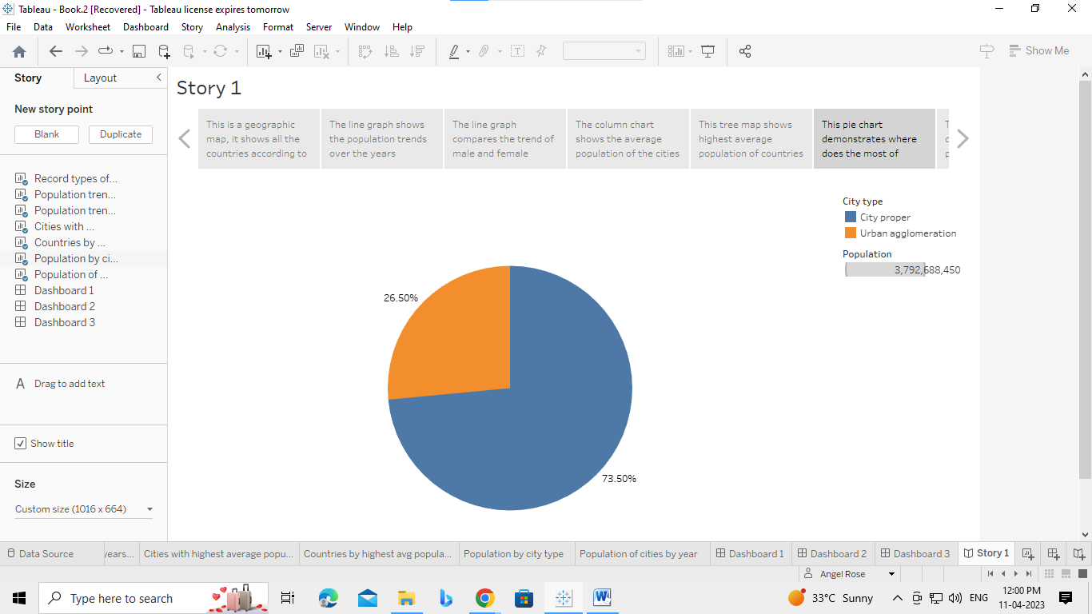

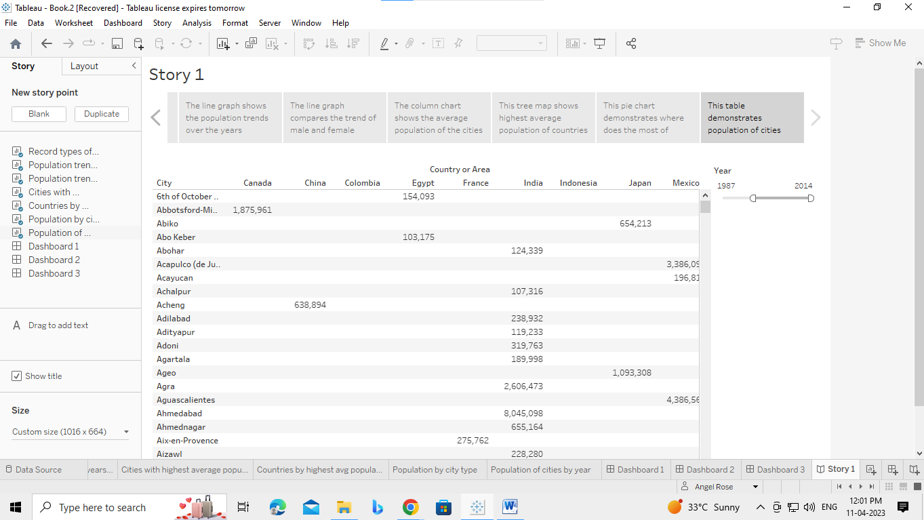

1. **ADVANTAGES AND DISADVANTAGES**

**Advantages**

* More people leads to greater human capital
* Higher economic growth
* Economies of scale
* The efficiency of higher population density
* The improved demographic structure of society
* Critical mass

**Disadvantages**

* Cost to the environment
* Congestion
* Water shortage
* Generationg unsustainable waste
* Problem of unemployment
* More pressure on land
* Pressure on environment
* Decrease of forest area
* Environment pollution
* Education
* Energy crisis

1. **APPLICATION**

Population growth will lead to economic growth with more people able to produce more goods. It will lead to higher tax revenues which can be spent on public goods, such as health care and environmental projects. Increased supply of labor. Increased productivity. Increased consumption. Higher quality of living.

1. **CONCLUSION**

The human population is larger than at any time in the past. 90% of children born today are likely to live in conditions far less healthy and properous than those in the industrialised world. The rate of growth has decreased nearly everywhere, and some countries are seeing population declines. Most developed nations have passed through the demographic transition and are in position to transition to ecologically sustainable economies.

1. **FUTURE SCOPE**

Population growth and economic development are causing several serious environmental problems in India. These include pressure on land, deforestation and water scarcity and water population. So we need to reduce the extraction of resources from the environment. A quantitative study of human distribution in a particular area or space. Variation in population density due to environmental or geographical condition. The demographic phenomenon like mortality, growth rate, birth rate, etc. is studied.

1. **APPENDIX**

Source Code: C:/MSU/abisha/ee.html